**Embry-Riddle Aeronautical University**

Prescott, Arizona

College of Engineering



Dylan Astrup, Designated Team Lead

Tesla Alford III

Titan Berson

Grant Carrabine

Hannah Spiller

Jacob Wolf

**Abstract**

This document outlines the tests that will be completed to validate the design of the ERH2 hydrogen production and storage system, including a detailed plan of the test procedures, test design, and instrumentation. An uncertainty analysis of each measurement is included and discussed to verify the validity of the testing results. A thorough safety plan and analysis is included to outline the team’s safety throughout testing.

**Table of Contents**

List of Figures vi

Nomenclature vii

1.0 Leak Detection 1

1.1 Objectives 1

1.2 Test Article 1

1.3 Success Criteria 1

1.4 Facilities 1

1.5 Instrumentation 1

1.6 Risk Analysis 1

1.7 Procedure 2

1.8 Post Test Analysis 2

2.0 Heating Amperage 2

2.1 Objectives 2

2.2 Test Article 2

2.3 Success Criteria 3

2.4 Facilities 3

2.5 Instrumentation 3

2.6 Risk Analysis 3

2.7 Procedure 4

2.8 Post Test Analysis 4

3.0 Valve Temperature 4

3.1 Objectives 5

3.2 Test Article 5

3.3 Success Criteria 6

3.4 Facilities 6

3.5 Instrumentation 6

6

6

3.6 Risk Analysis 6

3.7 Procedure 6

3.8 Post Test Analysis 6

4.0 Insulation Temperature 6

4.1 Objectives 7

4.2 Test Article 7

4.3 Success Criteria 7

4.4 Facilities 7

4.5 Instrumentation 7

4.6 Risk Analysis 8

4.7 Procedure 8

4.8 Post Test Analysis 8

5.0 Hydrogen Production 8

5.1 Objectives 8

5.2 Test Article 8

5.3 Success Criteria 9

5.4 Facilities 9

5.5 Instrumentation 9

5.6 Risk Analysis 10

5.7 Procedure 10

5.8 Post Test Analysis 10

6.0 Material Storage Capacity 10

6.1 Objectives 10

6.2 Test Article 10

6.3 Success Criteria 11

6.4 Facilities 11

6.5 Instrumentation 11

6.6 Risk Analysis 11

6.7 Procedure 11

6.8 Post Test Analysis 11

7.0 Hydrogen Release 12

7.1 Objectives 12

7.2 Test Article 12

7.3 Success Criteria 12

7.4 Facilities 12

7.5 Instrumentation 12

7.6 Risk Analysis 13

7.7 Procedure 13

7.8 Post Test Analysis 13

8.0 Flow Storage 13

8.1 Objective 13

8.2 Test Article 13

8.3 Success Criteria 14

8.4 Facilities 14

8.5 Instrumentation 14

8.6 Risk Analysis 14

8.7 Procedure 14

8.8 Post Test Analysis 14

# List of Figures

Figure 1: The Complete ERH2 System 1

Figure 2: Fabricated Pipe Assembly for Heating Amperage Test 3

Figure 3: Heating Amperage Test Assembly 4

Figure 4: Valve Temperature Check Setup. 5

Figure 5: Insulation verification test 7

Figure 6: Electrolysis production rate test set up 9

Figure 7: Material storage measurement test set up 11

Figure 8: Material storage flow test set up 14

# Nomenclature

|  |  |
| --- | --- |
| **Abbreviation** | **Definition** |
| ERH2 | Embry-Riddle Hydrogen |
| DTL | Designated Team Lead |
| H2 | Hydrogen Gas |
| ERAU | Embry-Riddle Aeronautical University |

# Leak Detection

This test aims to detect leaks in ERH2's system. This is critical for the system's success, as large leaks will prevent the system from producing enough hydrogen to charge the material storage and run the fuel cell.

## 1.1 Objectives

Detect leaks in the system (req 1.1.1).

## 1.2 Test Article

The Test Article is the complete assembly of ERH2’s system, it consists of the following components: The electrolyzer, the PTFE connectors, pressure gauge/thermocouple interfaces, and the stainless-steel pipe sub-assembly.

Figure 1: The Complete ERH2 System

## 1.3 Success Criteria

No bubbles are detected.

## 1.4 Facilities

Compressed air hose found in AXFAB and hand soap provided by Embry-Riddle.

## 1.5 Instrumentation

We will use visual checks to make sure that there are no bubbles forming at the interfaces of the system. The uncertainty associated with this test is the size of the bubbles that we can visually verify with hydrogen running through the system. The bubbles that form with the compressed air hose we will be able to see easily, but when we run the test with the produced hydrogen, the bubbles might be too small to verify. To ensure that the possible hydrogen leaks in the system are not critical, we will run the system with the electrolysis running to the fuel cell and if the fuel cell turns on, then we know that the possible hydrogen leaks are negligible to the success of the system.

## 1.6 Risk Analysis

The risks to the system from the bubble test is negligible because the pressure is low and the soap is non-toxic.

## 1.7 Procedure

At all interfaces and valves, apply soap mixture covering the interface. Connect the compressed air hose to the inlet of the electrolyzer. Run the compressed air through the system and document where bubbles occur. If the system passes the compressed air test, connect the electrolysis to the power supply and run the complete system to the fuel cell to determine if there is enough hydrogen produced to run the fuel cell. If it successfully runs the fuel cell, there are no catastrophic leaks in the system.

## 1.8 Post Test Analysis

While conducting the leak detection test, if any bubbles form, then a leak exists. The team will discuss ways of fixing said leak through a sealant and/or adhesive bonding agent. If no bubbles form, then the system has no significant leaks to account for and can continue in testing.

# 

# 2.0 Heating Amperage

This test aims to determine the amperage supplied to the nichrome wire required to keep the heating zone at 300°C. The success of the test depends on the proper wrapping of the nichrome wire to prevent shorting, as well as the ability to mitigate risks such as insulation adhesive melting and burn hazards. The results will inform the heating system design and ensure the effectiveness of the system in reaching the desired temperature.

## 2.1 Objectives

Determine the amperage supplied to the nichrome wire required to keep the heating zone at 300°C (req 1.2).

## 2.2 Test Article

The fabricated pipe assembly includes the stainless-steel pipe, nichrome wire, insulation, and K-type thermocouple. This is connected to the power supply and the appropriate amperage is applied.

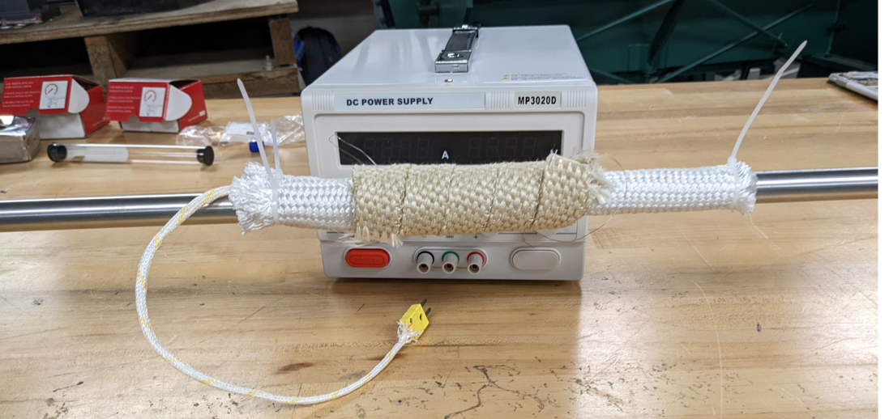

Nichrome Wire and Insulation

Thermocouple Reader

Figure 2: Fabricated Pipe Assembly for Heating Amperage Test

## 2.3 Success Criteria

The power supply heats the pipe to 300°C with less than 20 amps.

## 2.4 Facilities

Power supply, fabricated pipe assembly, thermocouple reader, thermal imaging camera.

## 2.5 Instrumentation

We will be using a K-type thermocouple to measure the temperature in the heating zone. The uncertainty of the temperature measurement is $±$ 2.6°C.

## 2.6 Risk Analysis

The risks to personnel performing this test are the insulation adhesive melting and the burn hazard of the hot pipe. These risks are mitigated by using a vent hood to flush the smell of the adhesive melting for the first time and PPE of welding gloves to ensure that no burns occur.

The risks to the equipment performing this test are minimal because the system and thermocouples are designed to reach temperatures up to 1000°C.

The risks to the success of the test are the way the nichrome wire was wrapped and the amount of current needed. Since we could not purchase electrically insulated nichrome wire, we had to carefully wrap it by hand to ensure that the coil does not touch itself. If parts of the wire are touching, it will short-circuit, and the heating zone becomes extremely small and requires more amperage to get to 300°C.

## 2.7 Procedure

Connect the power supply to the nichrome heating wire at the heating zone as demonstrated in Figure 1: Heating Amperage Test Assembly.

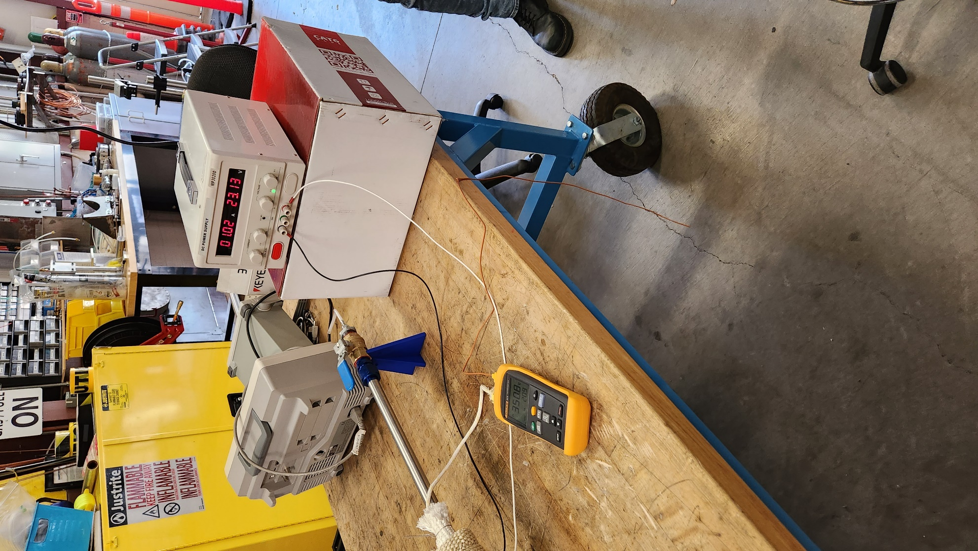

Nichrome wire & heating zone

Thermocouple Reader

Power Supply

Figure : Heating Amperage Test Assembly

Connect the thermocouple reader to the thermocouple, which was attached to the heating zone of the pipe assembly during test article fabrication.

Turn on the power supply, gradually increasing the current supplied to the heating wire until the thermocouple reader displays a constant value of 300°C. Record this value of current, and its corresponding value of voltage.

Repeat the above process for a measured temperature of 350°C.

## 2.8 Post Test Analysis

Using this test, we can find the steady state power requirements for 300°C and 350°C.

# 

# 3.0 Valve Temperature

This test aims to test the integrity of the pipe assembly by measuring the temperature of the ends of the pipe over time. Though the valves themselves can handle more than the requirement of 50°C, the fuel cell is fragile, and we do not want to expose it to extreme temperatures. The pipe is made of stainless steel, so it acts as a heat exchanger to draw the heat from the gas escaping the material storage.

## 3.1 Objectives

Ensure the ends of the pipe stay below 50°C when the heating zone is at 350°C.

## 3.2 Test Article

The fabricated pipe assembly includes the stainless-steel pipe, nichrome wire, insulation, and K-type thermocouple. This is connected to the power supply and the appropriate amperage is applied. The thermal imaging camera is used to measure the temperature at the end of the pipe over time.

Thermocouple Reader

Power Supply

Nichrome wire & heating zone

Figure : Valve Temperature Check Setup.

## 3.3 Success Criteria

The test is successful if the ends of the pipe do not exceed 50°C when the heating zone is at 350°C.

## 3.4 Facilities

Heating system, pipe to hold capsule, thermocouple, STEM 114 vent hood.

## 3.5 Instrumentation

We will be using a K-type thermocouple to measure the temperature in the heating zone. We will use a thermal imaging camera and a secondary K-type thermocouple to measure the temperature at the ends of the pipe. The uncertainty of the K-type thermocouple is 2°C and the uncertainty of the thermal imaging camera is 2.2°C.

Uncertainty in the measurement of the temperature at the end of the pipe:

$$∆T=\sqrt{\frac{d∆T}{dT_{1}}∆{T_{1}}^{2}+∆{T_{2}}^{2}}$$

$$∆T=±2.97°C$$

## 

## 3.6 Risk Analysis

The risks to personnel performing this test are the insulation adhesive melting and the burn hazard of the hot pipe. These risks are mitigated by using a vent hood to flush the smell of the adhesive melting for the first time and PPE of welding gloves to ensure that no burns occur.

The risks to the equipment performing this test are minimal because the system and thermocouples are designed to reach temperatures up to 1000°C.

The risks to the success of the test are the way the nichrome wire was wrapped and the amount of current needed. Since we could not purchase electrically insulated nichrome wire, we had to wrap it by hand carefully to make sure that the coil does not touch itself. If parts of it are touching, it will short circuit and the heating zone becomes extremely small and requires more amperage to get to 350°C.

## 3.7 Procedure

Connect power supply to heating element and place a thermocouple in the heating zone and at the end of the pipe where the valve is. Turn on the power supply and record the temperature of the heating zone and the end of the pipe over time. Stop test when the heating zone reaches 350°C.

## 3.8 Post Test Analysis

After completion of this test, we can compare and verify our heat transfer calculations to determine the best length for our system.

# 4.0 Insulation Temperature

This test aims to ensure that the insulation of ERH2's pipe assembly does not exceed the surrounding air temperature when the heating zone reaches 300°C.

## 4.1 Objectives

Test the outside temperature of the insulation at the heating zone. The heating zone will reach 300°C, but we cannot have that hot of a pipe exposed to viewers. 300°C is hot enough to give someone 3rd degree burns if they accidentally touch the pipe.

## 4.2 Test Article

To perform this test we will use the fabricated pipe assembly with nichrome wire, thermocouple, and insulation. The power supply is connected to the nichrome wire and current is applied to get the heating zone to 300°C.

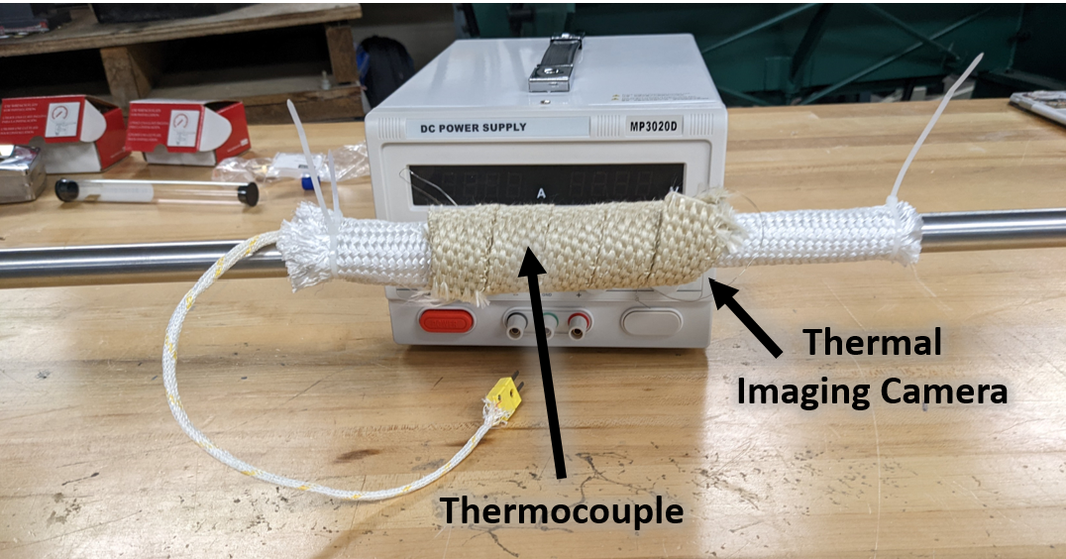

Figure 5: Insulation verification test

## 4.3 Success Criteria

The test is successful if the insulation temperature does not exceed the surrounding air temperature.

## 4.4 Facilities

Power supply, nichrome wire, stainless pipe, thermocouple, thermal imaging camera, STEM 114 vent hood

## 4.5 Instrumentation

To measure the temperature of the heating zone, we will be using the same K-type thermocouple as the previous tests. The uncertainty of this measurement is $±$ 2.6°C.

To measure the temperature of the surface of the insulation, we will use the thermal imaging camera. The uncertainty of the thermal imaging camera is $±$ 2.2°C.

## 4.6 Risk Analysis

The risk to the success of the test is the way the insulation was installed. We wrapped the insulation by hand so there could be insulation layers that shifted and cause hot spots on the surface. If this occurs, more insulation will be applied to those areas.

The risks to personnel from this test are burn hazards and the insulation tape melting. To mitigate this, welding gloves will be worn to ensure there are no burns and the test will be performed under a vent hood.

The risks to the system are negligible because all components are rated to withstand up to 1000°C.

## 4.7 Procedure

Connect the power supply to the nichrome wire heating zone. Supply the wire with the amperage determined in Test 2: Heating Amperage to make the heating zone 300°C. Measure the temperature of the insulation using the thermal imaging camera.

## 4.8 Post Test Analysis

After conducting this test, we can verify the exterior temperature of the insulation to account for any heat loss.

# 5.0 Hydrogen Production

This test aims to determine the amount of hydrogen produced by electrolysis and ensure that enough hydrogen is being produced to run the fuel cell and fill the material storage.

## 5.1 Objectives

Determine the amount of hydrogen produced by electrolysis. To fulfill system requirement 1.1.1, we need to produce enough hydrogen to run the fuel cell and fill the material storage. Since the volume of the system is large and the efficiency of the fuel cell is unknown, we need to know how much hydrogen we are producing at different amperages.

## 5.2 Test Article

The test article is the electrolyzer to the valve at the beginning of the fabricated pipe assembly. This includes the electrolyzer, PTFE, J-type thermocouple, pressure gauge, and valve.

Figure 6: Electrolysis production rate test set up

## 5.3 Success Criteria

The test is successful if the electrolysis produces at least 0.02 grams of hydrogen.

## 5.4 Facilities

STEM 114 vent hood, electrolysis to valve 1, pressure gauge, electrolysis thermocouple, and stopwatch.

## 5.5 Instrumentation

To measure the pressure and temperature of the hydrogen leaving the electrolysis unit, we are using a 4 inWC pressure gauge and J-type thermocouple. The pressure gauge has an uncertainty of $±$ 3-2-3% and the thermocouple has an uncertainty of $±$ 2.2°C. We will use the pressure and temperature of the gas to use the ideal gas law to determine the mass of hydrogen in the system.

The mass of hydrogen is found using the equation below:

$m=\frac{PV}{RT}$

Where:

$P$ = Absolute pressure of the gas (KPa)

$V$ = Volume of the gas (L)

$m$ = Mass of the gas (g)

$R$ = Ideal gas constant (KJ/KgK)

$T$ = Absolute temperature of the gas (K)

The uncertainty in the above mass measurement is:

$Δm=\sqrt{{(\frac{V}{RT}∆P)}^{2}+{(\frac{P}{RT}∆V)}^{2}+{(\frac{PV}{RT^{2}}∆T)}^{2}}$

Where:

$ΔP$ = Uncertainty in pressure of the gas (KPa)

$ΔV$ = Uncertainty in volume of the gas (L)

$Δm$ = Uncertainty in mass of the gas (g)

$ΔT$ = Uncertainty in temperature of the gas (K)

$$Δm=±0.00264 g$$

## 5.6 Risk Analysis

The risk to the success of the test is the production rate being too fast to accurately measure pressure and temperature.

The risks to personnel running the test are negligible due to the design of the electrolyzer and administrative controls.

The risks to the system from this test are also negligible because the system was designed to produce hydrogen and hold pressures up to 4 in-WC.

## 5.7 Procedure

Fill electrolyzer with salt solution and ensure safe electrical connection. Turn on power supply to 5 amps and recorded the pressure change over time until the maximum pressure of 4-inWC. Vent hydrogen into the vent hood and repeat the process at 10, 15, and 20 amps.

## 5.8 Post Test Analysis

Using the ideal gas law, we can calculate the mass of hydrogen that is produced over a time period. This will give us the production rate of our electrolysis at different amperages.

# 6.0 Material Storage Capacity

This test aims to determine material storage capacity to experiment and study the material storage limits.

## 6.1 Objectives

Determine material storage capacity. This test fulfills system requirement 1.2 that mandates that the material storage must run the fuel cell for at least 5 minutes. In order to determine if this is possible, we need to know how much hydrogen the material can hold at one time.

## 6.2 Test Article

The entire ERH2 system including all parts from the electrolysis to the fuel cell.

Figure 7: Material storage measurement test set up

## 6.3 Success Criteria

The test is successful if the final mass of the capsule is at least 0.02 grams heavier than the initial mass.

## 6.4 Facilities

STEM 114 vent hood, electrolysis to material storage system, material storage capsule, pressure gauge, scale.

## 6.5 Instrumentation

We will measure the amount of hydrogen stored in the material using the chemistry scale. The difference between the final and the initial mass of the capsule will be the hydrogen stored.

To determine the small amount of hydrogen stored, the uncertainty needs to be ±0.005 or better because we need to store 0.02 grams of hydrogen. The uncertainty of the chemistry scale is ±0.0005 grams, fulfilling the minimum uncertainty.

Cotton gloves will be worn when handling the capsule to ensure that no extra dirt or finger oil will be measured. Also, to determine the uncertainty of the initial capsule, the capsule will be weighed, inserted into the pipe, taken out, and reweighed. This process will be repeated 5 times.

## 6.6 Risk Analysis

The risks to the success of this test are the limits of the material storage material. We do not know how long it takes to fill the material storage or how much this material will hold. Since we bought the material online, we do not know the purity or the exact structure, and this could change the capacity.

The risks to personnel are minimal because of administrative controls like PPE and the vent hood.

The risks to the system are negligible because through previous testing all of the risks have been resolved.

## 6.7 Procedure

Insert the capsule into the heating zone and heat at 80°C for 2 minutes to dry the material fully. Remove the material capsule and weigh, record the mass. The capsule will be inserted into the system again and a system flush will be done. After the flush the valve to the fuel cell will be closed and the electrolyzer will run until maximum pressure is reached. Then the valve will open again to vent the hydrogen out of the system and the capsule will be removed and weighed again. Using the capacity equation, the material storage wt % of hydrogen is found.

## 6.8 Post Test Analysis

To determine the capacity of the material storage, we will take the data found by the test to determine the %wt of hydrogen of the material. That is found using the equations below: $$m_{H_{2}Stored}=m_{final}-m_{initial}$$

$$\%_{wtH_{2}}=\frac{m_{H_{2}Stored}}{m_{initial}}$$

# 

# 7.0 Hydrogen Release

This test aims to determine the material storage release behaviors. Hydrogen material storage has very little existing research, including any release information such as release rate.

## 7.1 Objectives

Determine how much hydrogen can be released by the material storage. This also pertains to requirement 1.2 for running the fuel cell for a minimum of 5 minutes. We need to determine the amount of hydrogen the material can release and how fast it releases to fulfill the requirement.

## 7.2 Test Article

The entire ERH2 system from the electrolysis to the fuel cell.

Figure 8: Material storage measurement test set up

## 7.3 Success Criteria

The test is successful if the pressure gauge indicates a change in pressure equivalent to 0.02 grams of hydrogen over a 10 minute time period.

## 7.4 Facilities

STEM 114 vent hood, electrolysis to material storage system, material storage capsule, pressure gauge, scale.

## 7.5 Instrumentation

To measure the amount of hydrogen released, we will use a stopwatch, pressure gauge, chemistry scale, and J-Type thermocouple. The scale uncertainty is $±$ 0.0005 grams and we will be using gloves to make sure the measurement is not contaminated. The stopwatch will be from a smart phone so the uncertainty will be is $±$ 1.0 second due to reaction time. The pressure gauge’s uncertainty is $±$ 3-2-3% depending on the measurement. The K-Type thermocouple has an uncertainty of is $±$ 2.2°C. Since we are finding the mass of hydrogen released, we will use the ideal gas law with an uncertainty calculation found above in section 5.5.

## 7.6 Risk Analysis

The risks to the success of this test are the limits of the material storage material. We do not know how long it takes to release hydrogen from the material storage. Since we bought the material online, we do not know the purity or the exact structure, this could change the capacity.

The risks to personnel are minimal because of administrative controls like PPE and the vent hood.

The risks to the system are negligible because through previous testing all the risks have been resolved.

## 7.7 Procedure

Perform the procedure outlined in section 6.7. Reinsert the capsule into the system and align it in the heating zone. Run a flush on the system. Keep exit valve open and crimp the end that would run into the fuel cell. Record the temperature of the heating zone every 5 minutes until it reaches 300°C. Once the pressure gauge indicates an increase in pressure, record changes in the pressure over time and the temperature at that time. Once pressure gauge stops changing, vent the hydrogen into the vent hood, remove capsule when thermocouple indicates a safe temperature, and weigh again.

## 7.8 Post Test Analysis

Weigh the material storage capsule again to determine the mass of hydrogen released.

$$m_{H_{2}Released}=m_{final}-m_{initial}$$

$$Δm=±0.0005 g$$

# 

# 8.0 Flow Storage

This test aims to research the material storage behaviors further by studying if the material storage can absorb hydrogen while the hydrogen flows over the material, as opposed to the hydrogen stagnantly surrounding the material.

## 8.1 Objective

Determine if the material storage can load while hydrogen runs from the electrolyzer to the fuel cell (req 1.2).

## 8.2 Test Article

The entire ERH2 system including all parts from the electrolysis to the fuel cell.

Figure : Material storage flow test set up

## 8.3 Success Criteria

The material storage exhibits the same final mass after loading as found in test 6: Material Storage Capacity.

## 8.4 Facilities

STEM 114 vent hood, electrolysis to fuel cell configuration, scale

## 8.5 Instrumentation

We will measure the amount of hydrogen stored in the material using the chemistry scale. The difference between the final and the initial mass of the capsule will be the hydrogen stored. To determine the small amount of hydrogen stored, the uncertainty needs to be ±0.005 or better. The uncertainty of the chemistry scale is ±0.0005 grams, fulfilling the minimum uncertainty. Cotton gloves will be worn when handling the capsule to ensure that no extra dirt or finger oil will be measured. To measure the uncertainty of the repeated weighing, we will weigh the capsule, insert it in the system, remove it from the system, and reweigh 5 times.

## 8.6 Risk Analysis

The risks to the success of this test are the limits of the material storage material. We do not know if the material will absorb flowing hydrogen. Since we bought the material online, we do not know the purity or the exact structure, this could change the capacity.

The risks to personnel are minimal because of administrative controls like PPE and the vent hood.

The risks to the system are negligible because through previous testing all the risks have been resolved.

## 8.7 Procedure

Insert the capsule into the heating zone and heat at 80°C for 2 minutes to dry the material fully. Remove the capsule and weigh it using the chemistry scale. Put the capsule back in the heating zone and connect the system in the electrolyzer to fuel cell configuration with both valves open. Turn on the electrolyzer and run the fuel cell for 10 minutes. Turn off the electrolyzer and remove capsule and weigh again. Record the difference and compare the results to the material capacity test.

## 8.8 Post Test Analysis

To determine the capacity of the material storage, we will take the data found by the test to determine the %wt of hydrogen of the material. That is found using the equations below: